EES Gas Emittance

EES has tabulated data for gaseous emission. This data is useful in determining the radiant heat flux on a surface based on the volumetric emissivity of gases. The data available is based off of the work of Hottel1. The data is of the emissivity of a hemispherical volume of gas, at temperature T_{g}, as measured by a small surface element positioned in the center of the hemisphere. The length term used in the subsequent tables and function use a length term equal to the radius of the hemisphere.

In the gas emittance subdirectory, tables emittance_CO2 and emittance_H2O correspond to the emissivities of carbon dioxide and water respectively in a mixture with non radiating gases. The tables are ordered as emissivity as a function of gas temperature for distance-pressures 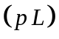. Shown below are plots based on the tables for the entire data range available.

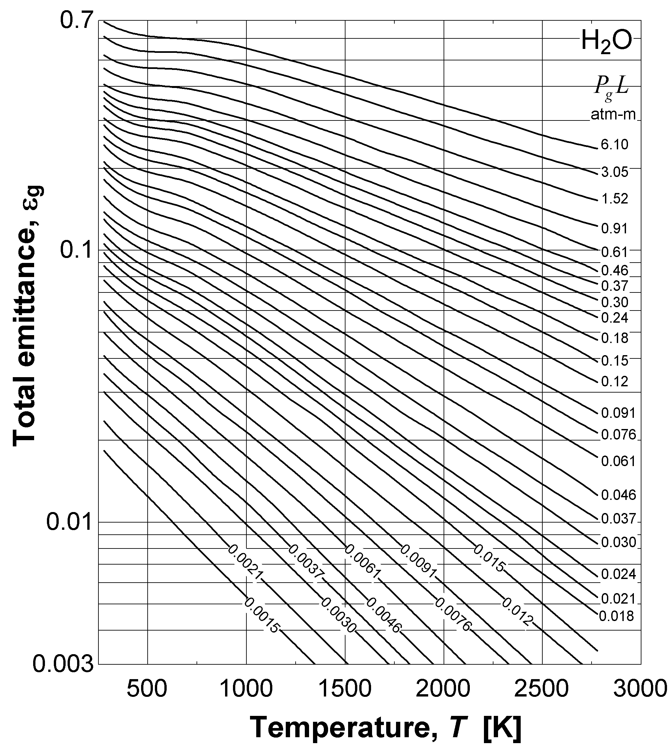
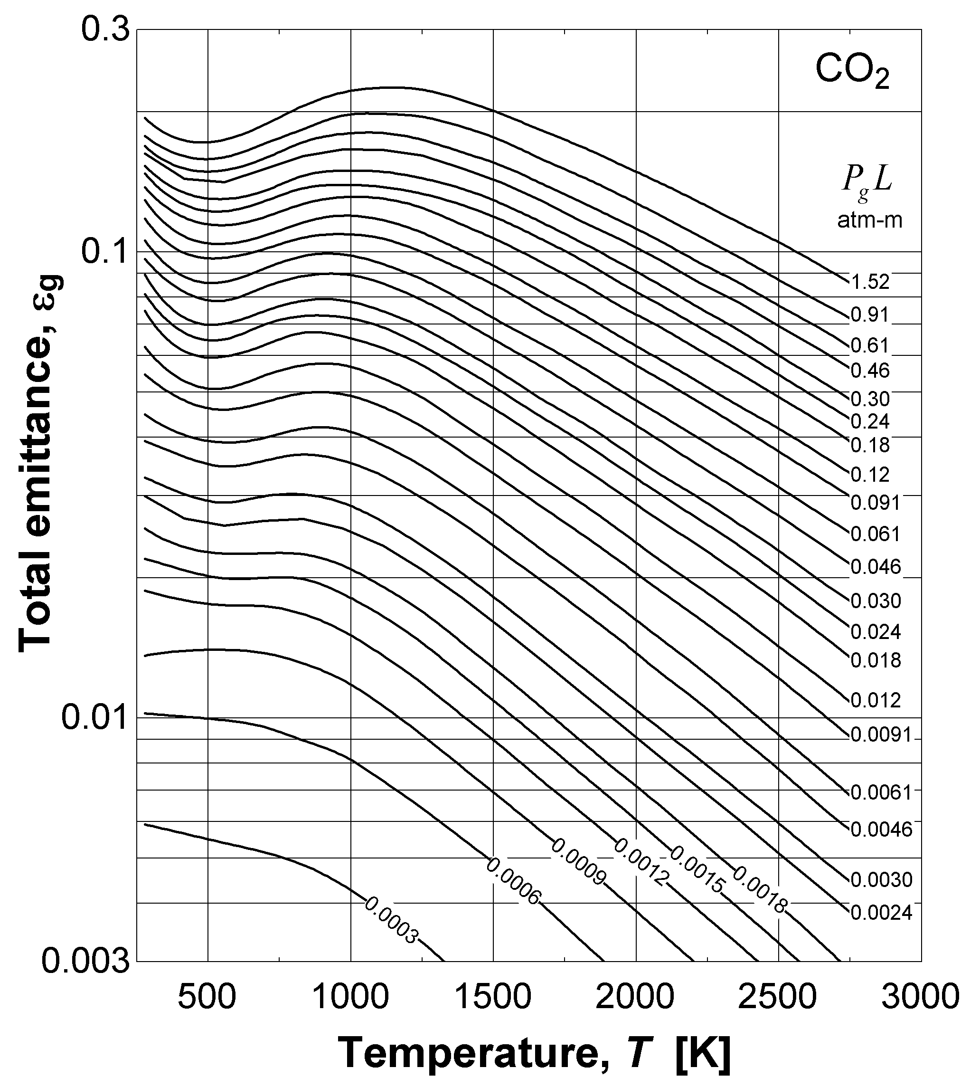

Figure 1: Total emittance as a function of temperature for varying gas pressure-length. The gas pressure-length term is given in units of [atm-m], while the gas temperature is given in [K]. If using the data tables directly, it is important to express the row and column values in the aforementioned units.

Since the emissivity tables for carbon dioxide and water vapor apply for a gas pressure of 1 [atm], a correction factor must be applied for differing values. Tables emittance_CO2_CF and emittance_H2O_CF give the correction factor in terms of pressure for various partial pressure-length terms. For carbon dioxide, the total pressure and the partial pressure-length term are used. For water vapor, the average of the partial and total pressure along with thet partial pressure-length term are used. The units are specified as [atm] for the pressure terms and [atm-m] for the pressure-length terms. Shown below are plots based on the tables for the entire data range available.
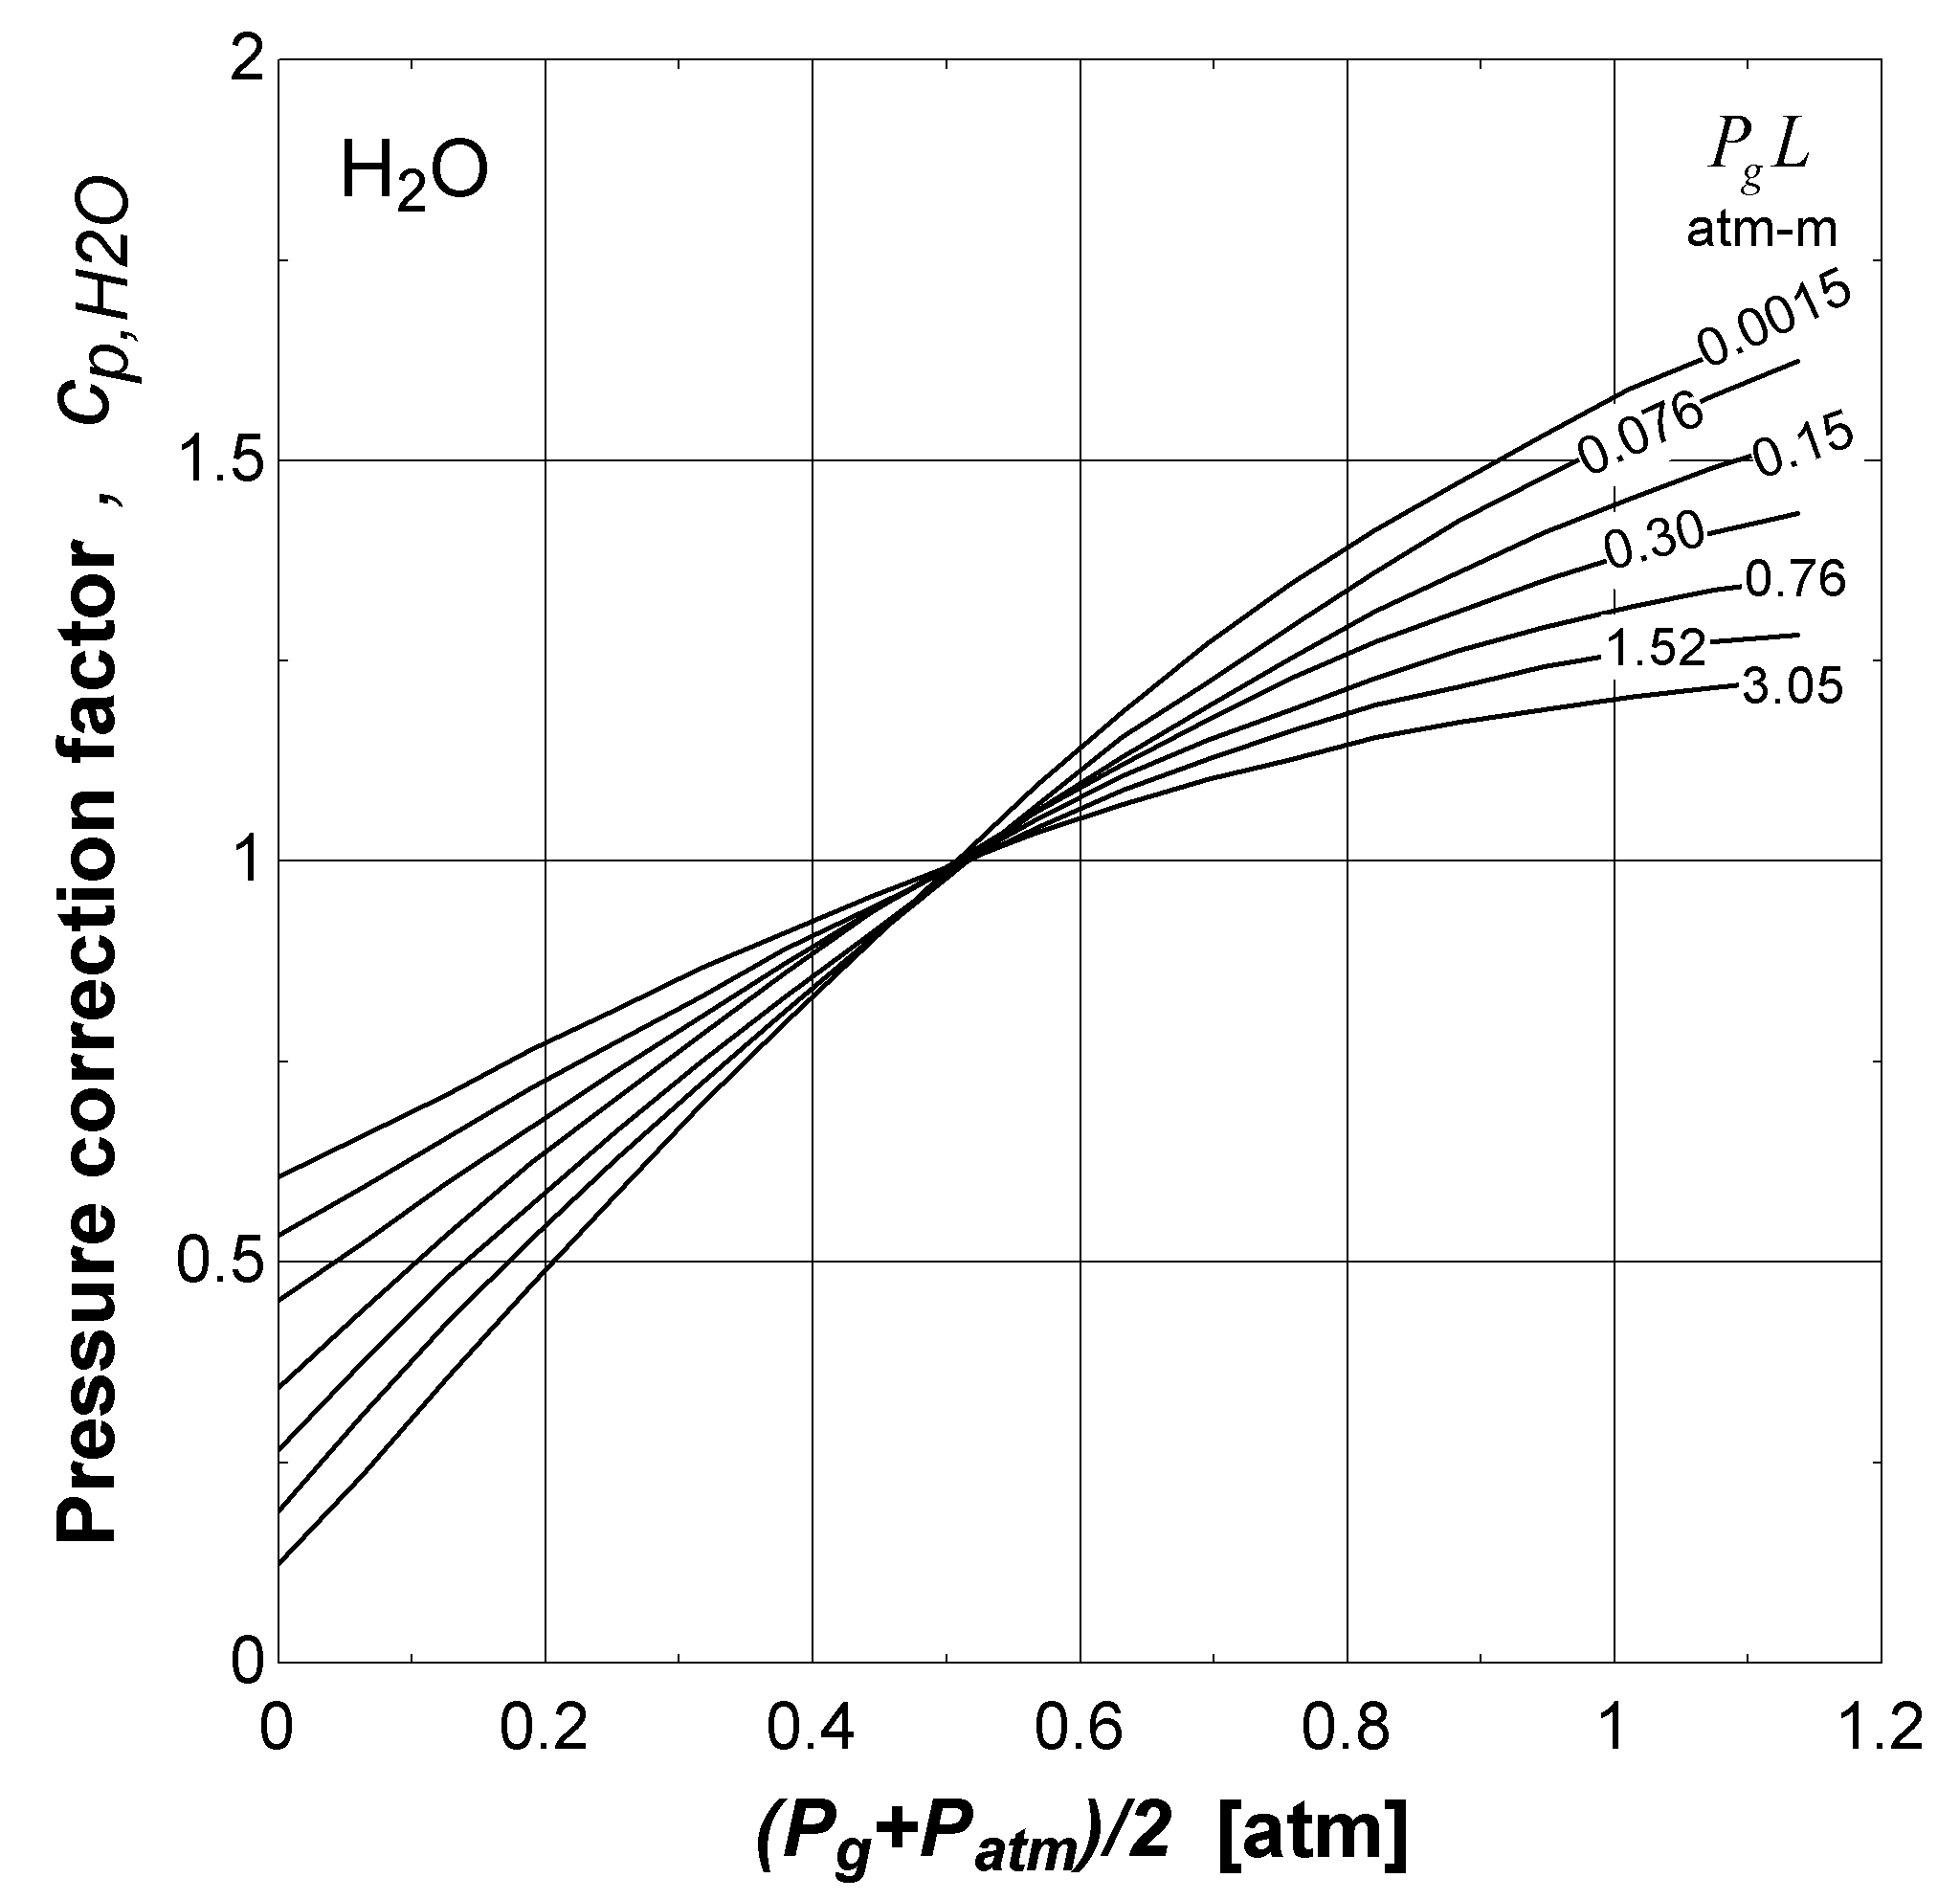
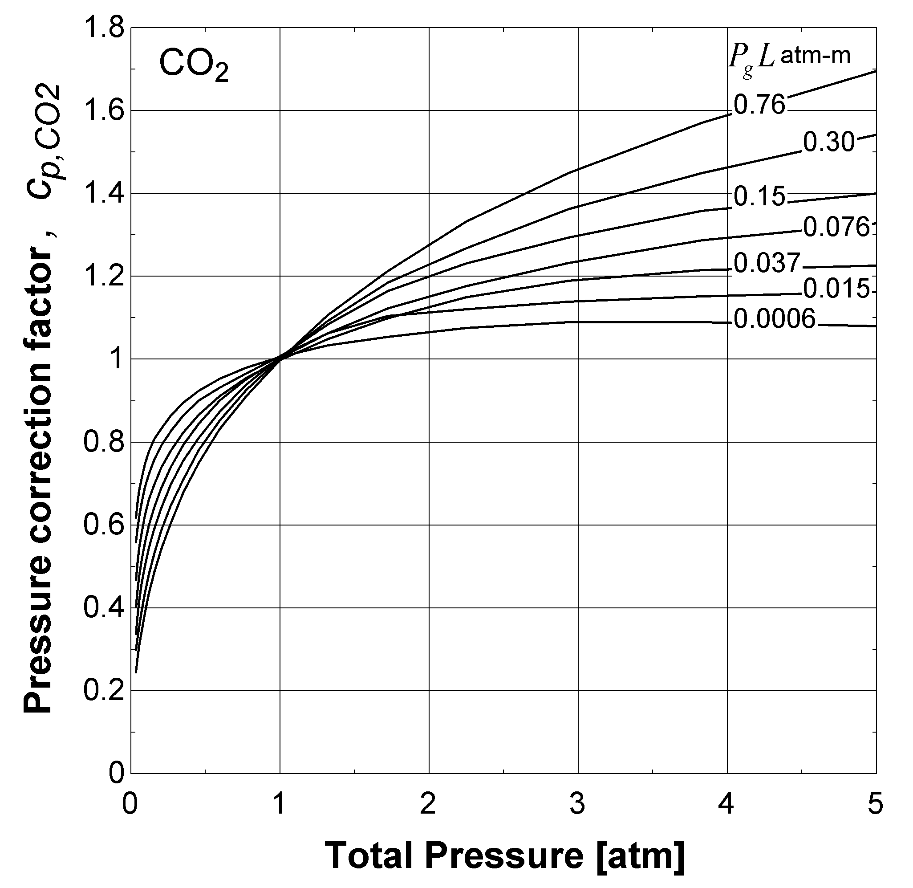

Figure 2: For carbon dioxide or water pressures other than 1 [atm], a correction factor is applied. Correction factor is a function of total pressure for carbon dioxide and, for water vapor, the average of the partial pressure and the gas pressure. The gas pressure-length term is given in units of [atm-m], while the gas pressure is given in [atm]. If using the data tables directly, it is important to express the row and column values in the aforementioned units.

If the mixture under consideration is a combination of water vapor and carbon dioxide, an additional band overlap correction factor should be applied. This correction factor is based on the relative pressure of the water vapor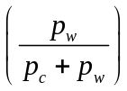 for varying mixture pressure-length at three different temperature ranges. The mixture pressure is given as 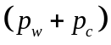. The units are specified as [atm] for the pressure terms and [atm-m] for the pressure-length terms. Shown below are plots based on the tables for the entire data range available.

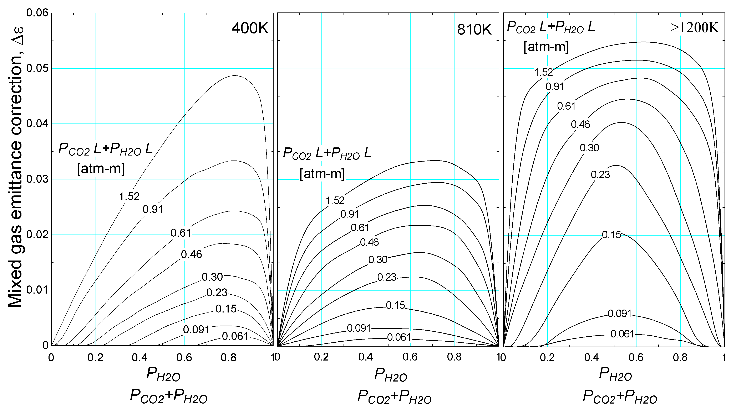

Figure 3: For carbon dioxide/water vapor mixtures, a correction factor is used. The correction factor is a function of the mixture temperature and the mixture pressure-length. The gas pressure-length term is given in units of [atm-m], while the gas pressure is given in [atm]. If using the data tables directly, it is important to express the row and column values in these units.

Rather than interpolating and multiplying correction factors for each table, EES offers a function which will automatically solve for gas emissivities involving carbon dioxide and water vapor.

The function emittance_CO2&H2O(p_w, p_c, p_tot, L, T_g) determines the emissivity of a carbon dioxide/water vapor mixture.

Inputs:
p_w – partial pressure of water vapor
p_c – partial pressure of carbon dioxide
p_tot – total pressure, including water vapor, carbon dioxide, and non-participating gases
L – radius of the hemisphere (also can be extended to surfaces other than a small surface element at the center of the hemisphere)
T_g – temperature of the all of the gases

Note: All of the pressure and temperature terms should be entered in the units selected in the preferences. The length should be specified as [m] (in SI) and [ft] (in ENG).

